Lab: Lists
Problems for exercises and homework for the "Programming Fundamentals" course @ SoftUni
You can check your solutions in Judge.

Sum Adjacent Equal Numbers
Write a program to sum all adjacent equal numbers in a list of decimal numbers, starting from left to right.
- After two numbers are summed, the obtained result could be equal to some of its neighbors and should be summed as well (see the examples below).
- Always sum the leftmost two equal neighbors (if several couples of equal neighbors are available).

Examples
Input | Output | Explanation
3 3 6 1 | 12 1 | 3 3 6 1 → 6 6 1 → 12 1
8 2 2 4 8 16 | 16 8 16 | 8 2 2 4 8 16 → 8 4 4 8 16 → 8 8 8 16 → 16 8 16
5 4 2 1 1 4 | 5 8 4 | 5 4 2 1 1 4 → 5 4 2 2 4 → 5 4 4 4 → 5 8 4
0.1 0.1 5 -5 | 0.2 5 -5 | 0.1 0.1 5 -5 → 0.2 5 -5

Solution
Read a list from numbers.
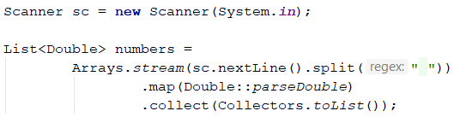
Iterate through the elements. Check if the number at the current index is equal to the next number. If it is, aggregate the numbers and reset the loop, otherwise don't do anything.
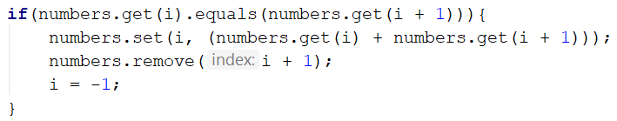
Finally, you have to print the numbers joined by space.
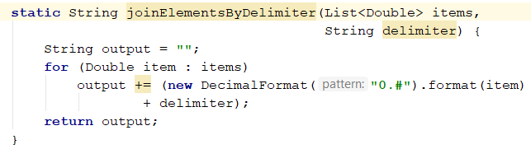

Gauss' Trick
Write a program that sum all numbers in a list in the following order:
first + last, first + 1 + last - 1, first + 2 + last - 2, … first + n, last - n.

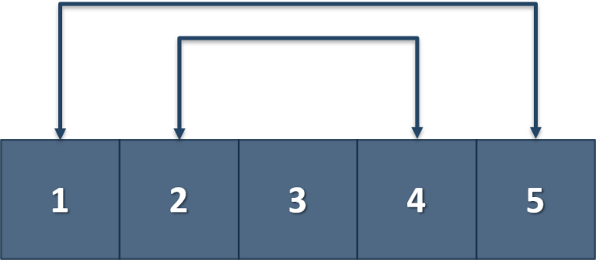

Example
Input | Output
1 2 3 4 5 |  | 6 6 3
1 2 3 4 | 5 5

Merging Lists
You are going to receive two lists with numbers. Create a result list that contains the numbers from both of the lists. The first element should be from the first list, the second from the second list, and so on. If the length of the two lists is not equal, just add the remaining elements at the end of the list.

Example
Input | Output
3 5 2 43 12 3 54 10 23  76 5 34 2 4 12 | 3 76 5 5 2 34 43 2 12 4 3 12 54 10 23
76 5 34 2 4 12  3 5 2 43 12 3 54 10 23 | 76 3 5 5 34 2 2 43 4 12 12 3 54 10 23

Hint
- Read the two lists.
- Create a result list.
- Start looping through them until you reach the end of the smallest one.
- Finally, add the remaining elements (if any) to the end of the list.

List Manipulation Basics
Write a program that reads a list of integers. Then until you receive "end", you will be given different commands:
Add {number}: add a number to the end of the list
Remove {number}: remove a number from the list
RemoveAt {index}: remove a number at a given index
Insert {number} {index}: insert a number at a given index
Note: All the indices will be valid!
When you receive the "end" command print the final state of the list (separated by spaces).

Example
Input | Output
4 19 2 53 6 43  Add 3  Remove 2  RemoveAt 1  Insert 8 3  end | 4 53 6 8 43 3
12 34 100 1 45 2 8  Add 30  Remove 12  Remove 3  RemoveAt 3  Insert 2 3  end | 34 100 1 2 2 8 30

Solution
First let us read the list from the console.
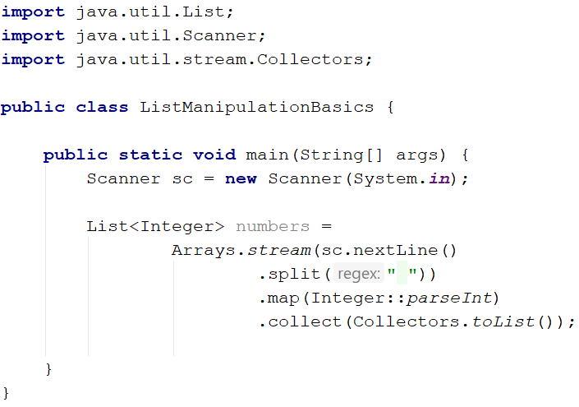
Next, we make the while loop for the commands and make a switch statement for the commands.
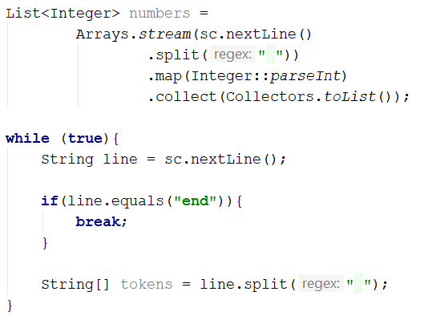
We break if the line is "end", otherwise, we split it into tokens and process the command.
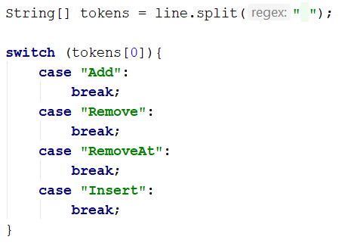
Now let's implement each command.
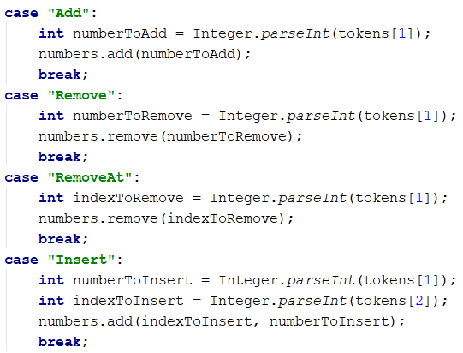
For all commands except the "Insert", tokens[1] is the number/index. For the "Insert" command we receive a number and an index (tokens[1], tokens[2]).
Finally, we print the numbers, joined by a single space:
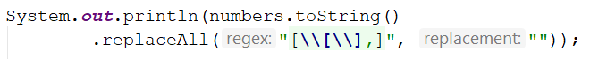

List Manipulation Advanced
Now we will implement more complicated list commands. Again, read a list, and until you receive "end" read commands:
Contains {number} – check if the list contains the number. If yes print "Yes", otherwise print "No such number"
Print even – print all the numbers that are even separated by a space
Print odd – print all the numbers that are oddly separated by a space
Get sum – print the sum of all the numbers
Filter {condition} {number} – print all the numbers that fulfill that condition. The condition will be either '<', '>', ">=", "<="

Example
Input | Output
2 13 43 876 342 23 543  Contains 100  Contains 543  Print even  Print odd  Get sum  Filter >= 43  Filter < 100  end | No such number  Yes  2 876 342  13 43 23 543  1842  43 876 342 543  2 13 43 23
12 3 123 546 222 45 7  Contains 3  Contains 121  Print even  Print odd  Get sum  Filter >= 100  Filter < 45  end | Yes  No such number  12 546 222  3 123 45 7  958  123 546 222  12 3 7
List of Products
Read a number n and n lines of products. Print a numbered list of all the products ordered by name.

Examples

Input | Output
4  Potatoes  Tomatoes  Onions  Apples | 1.Apples  2.Onions  3.Potatoes  4.Tomatoes
3  Orange  Grape  Strawberry | 1.Grape  2.Orange  3.Strawberry

Solution
First, we need to read the number n from the console.
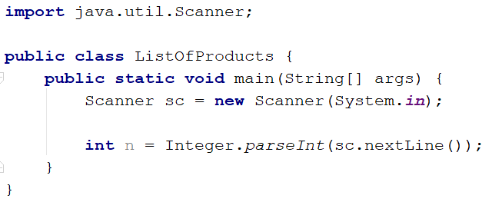
Then we need to create our list of strings because the products are strings.
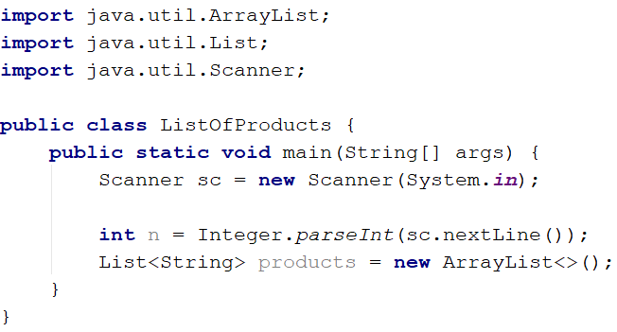
Then we need to iterate n times and read products.
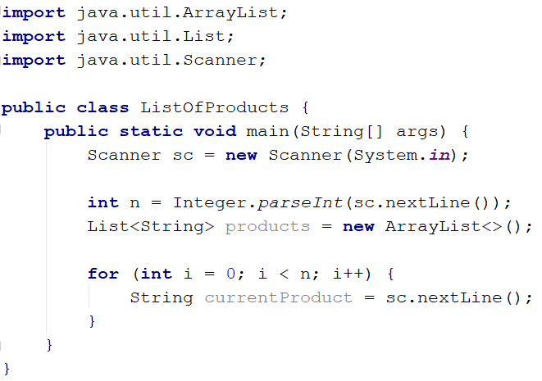
The next step is to add the current product to the list.
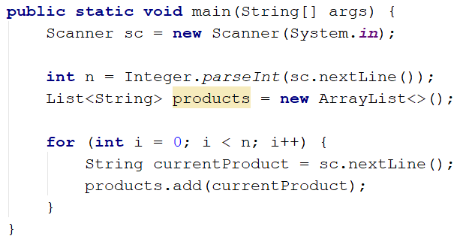
After we finish reading the products we sort our list alphabetically.
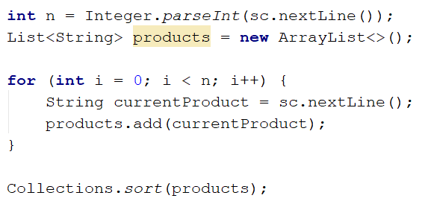
The sort method sorts the list in ascending order.
Finally, we have to print our sorted list. To do that we loop through the list.
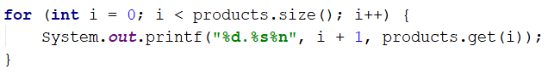
We use i + 1 because we want to start counting from 1.

Remove Negatives and Reverse
Read a list of integers, remove all negative numbers from it and print the remaining elements in reversed order. In case of no elements left in the list, print "empty".

Examples
Input | Output
10 -5 7 9 -33 50 | 50 9 7 10
7 -2 -10 1 | 1 7
-1 -2 -3 | empty

Solution
Read a list of integers.
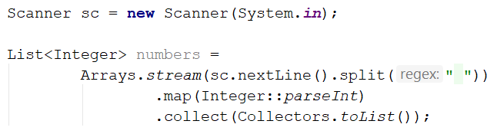
Remove all negative numbers and reverse the collection.
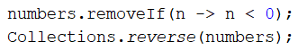
If the list is empty print "empty", otherwise print all numbers joined by space.
